2026-2027 IQC COMMUNITY ASSISTANCE PROJECT

REQUEST FOR PROPOSALS

Thank you for your interest in working with the University of Oklahoma Institute for Quality Communities on your project!

The Institute for Quality Communities (IQC) is the community outreach arm of the Christopher C. Gibbs College of Architecture at the University of Oklahoma. The IQC employs graduate assistants who commonly work on projects related to community engagement, environmental design, historic preservation, land use, public spaces, streetscapes, urban design, and other aspects of the built environment. Additionally, studio and lecture courses may take on projects with a particular emphasis on multi-family housing, senior housing, health and wellness, transportation, commercial and industrial building types, and cultural facilities.

Projects are a collaborative effort with support from community partners and various entities. Acceptance of the project is not incumbent upon funding; however, in-kind support, donated resources, and financial support are encouraged. The Oklahoma Municipal League may offer matching grants to qualifying applicants. Accepted proposals result in conceptual design and planning assistance developed by IQC staff, affiliated faculty, and students. For more information on how the community assistance process works, visit our website.

2026-2027 Project Timeline:
- Feb. 15th: RFP opens
- March 15th: Proposal deadline
- April-May: Project interviews and selection
- Fall 2026 – Spring 2027: Project collaborations

Once your proposal is submitted, an IQC team member will contact you as updates become available. Please reach out via e-mail at iqc@ou.edu with any questions.

CONTACT INFORMATION

- Project contact name and role:

- Organization/Municipality:

- Phone number (please include area code):

- E-mail address:

IQC ENGAGEMENT

- Please tell us how you heard / learned about the Institute for Quality Communities (IQC):

- Have you previously applied for assistance through the IQC?

- To your knowledge, has the IQC worked in your community before?

- Have you attended the IQC’s Placemaking Conference in the past?

- Would you like to receive news and updates from the IQC, including information about the upcoming 2027 Placemaking Conference in Norman?

COMMUNITY SNAPSHOT
- Briefly share your community's story. What makes it unique? (People, places, spaces, legacies, culture, etc.):

PROJECT SITE
- Physical address of project site. If no address, please describe the general physical location (i.e.: identify the closest major intersection):

- What is the size (sq ft or acreage) of the building/site?

- Who owns the property/site?

- Please upload 2-3 representative images of the site. One should be a site map (a Google map snapshot is fine). Ex. South Oval, OU-Norman campus.

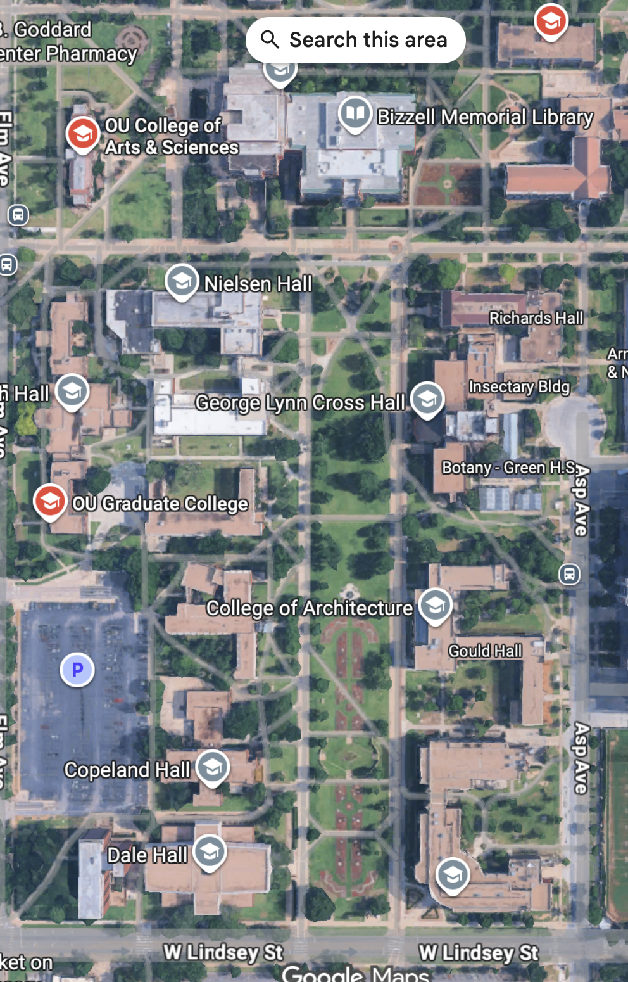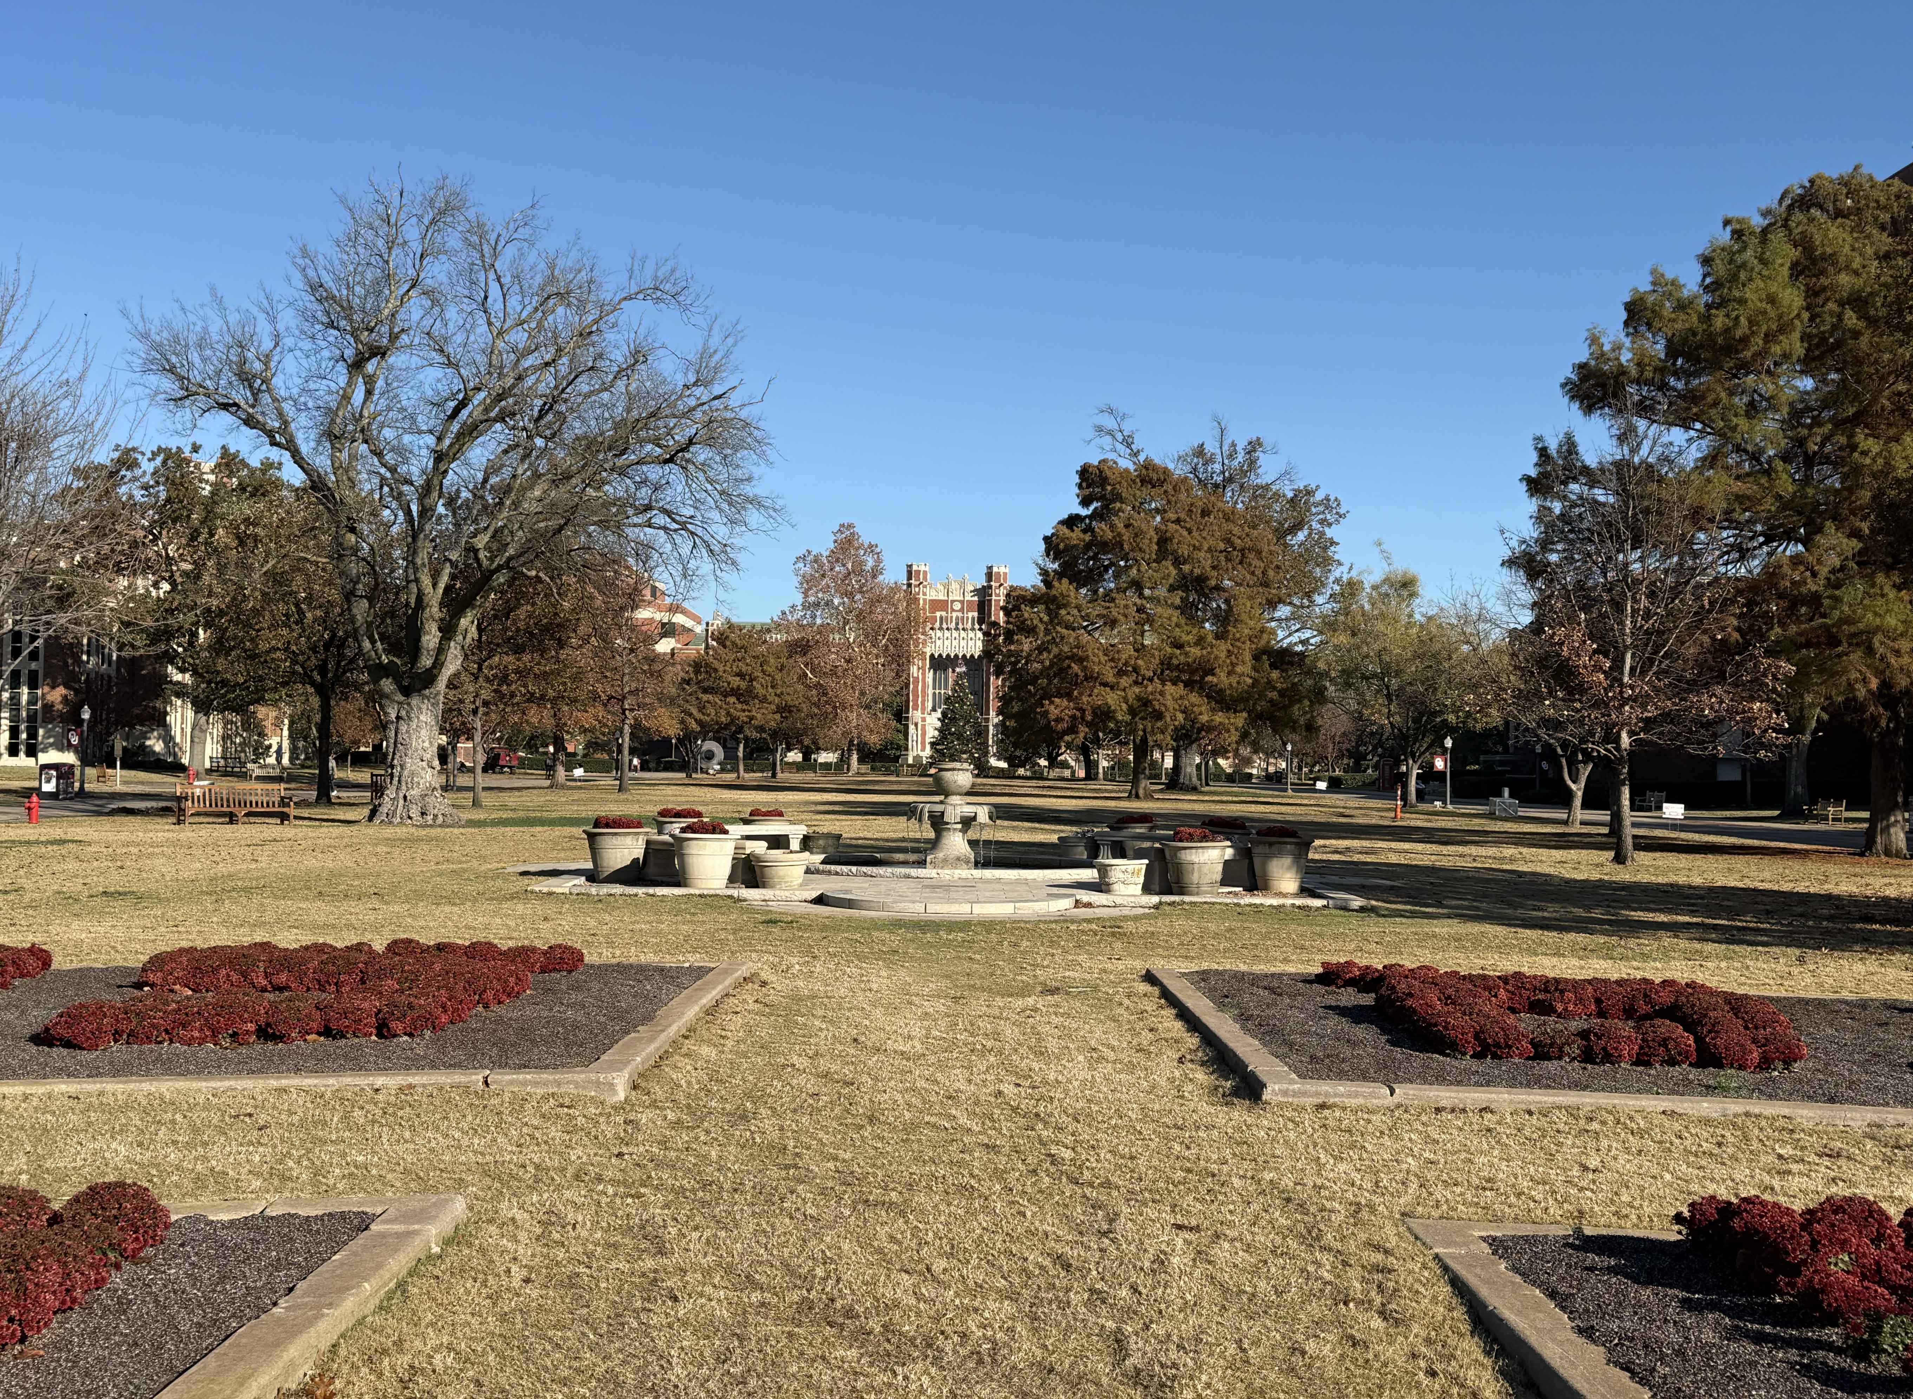

PROJECT DESCRIPTION

- Briefly describe your project through the following 3 prompts:

  - What is the intention and goal?
  - What are some desired outcomes of the project?
  - What is the built environment aspect of the project? (street, park, public space, downtown, building, etc.)

- How does this project advance community goals or priorities?

COMMUNITY CAPACITY

- Describe some challenges that your community is facing that could potentially impact the project:

- Who are the supporters/collaborators involved? (individual people, organizations, businesses, etc.)

PROJECT FUNDING
IQC Community Assistance Projects incur several costs including faculty and student compensation, travel, supplies/materials, printing, etc. Please note that project selection is not contingent on funds.
- Describe any funding or other resources that have already been identified by the applicant for the project.

The Oklahoma Municipal League (OML) can provide matching funds to support projects when available. To be eligible for OML funding, the project city must be a member of OML and be partnered on this project. Would you like to be considered for OML funding?

- Yes
- No

LETTERS OF SUPPORT

Please submit 1-3 letters of support along with your proposal to iqc@ou.edu. To be considered for OML funding, a letter must be provided from the local government staff representative who is a partner on this project.

